Abstract—IoT is the network of physical objects-devices, vehicles, buildings and other items embedded with electronics, software, sensors, and network connectivity-that enables these objects to collect and exchange data. Radio frequency identification (RFID) is a new generation of Auto Identification and Data collection technology, which helps to automate business process and identifies a large number of tagged student details using radio waves. In recent years, there has been a rise in the number of applications based on Radio Frequency Identification (RFID) systems and is successfully functional in different areas. In this project, an IoT based attendance management system which updates the student’s attendance in server with minimal human effort is implemented and the updated data can be accessed from anywhere from the identified user. In addition to this functionality; a student or faculty can download or upload notes from/to the server, SMS or push notifications can be sent to the respective mobiles from the administrator. The system also has the ability to handle proxy. The solution proposed is as follows: Once, all the students’ RFID tags are detected, our system initiates the camera to bag the number of head counts in the classroom. This system helps in managing the activities like student admission, student registration, timetable management and result declaration. Admin is the super user and can access any student’s / faculty’s details. Student can check their result online by logging into the system. This system facilitates colleges to maintain the functionality related to college employees and their students. It also helps teachers to update the internal marks, attendance etc.
IoT Based Smart Campus
1.Nishita Pal 2. R. Saiprasanth 3. Soorya Sahar P. N 4. Spoorthi S
Mr. Devaraju B.M
Dept. of Computer Science and Engineering
Keywords: Internet of Things, RFID, Smart campus

INTRODUCTION
An organization is fundamentally dependent on its workforce, with it being its biggest expense as well as its chief reason for generating revenue, growth and profit. As such it becomes essential to maintain reliable time and attendance information to make human resource management a lot easier. Radio Frequency Identification (RFID) uses electromagnetic fields to automatically identify and track tags attached to objects. The tags contain electronically-stored information. IoT technology facilitates automatic wireless identification using electronic passive and active tags with suitable readers. The technique proposed is much more advantageous, secure and easy with lower overhead in contrast with the other conventional technique used. It is much faster than the present system and has two components i.e. RFID tag and RFID reader. Information plays a vital role in the development and growth of every organization. The project aims to avail information or data to every user irrespective of his location. The system includes an application which is available to a faculty and a student. Functionalities provided for both of them are slightly different, in most of the situations a faculty is given the privilege of “write “as one might want to upload notes, update students ‘marks, attendance etc. On the other hand, students are mostly give the privilege of “view” where in he or she can view marks, notes that has been uploaded for the respective subjects. The application also has an about section which includes an individual’s name, gender and other personal details. Any changes done in the personal details by the user will directly reflect in the database. Another issue faced in an educational organization is Attendance Management. When a faculty walks into the class, his motive is only to educate the crowd and the time allocated must be completely utilized only to satisfy his/her motive. Instead, the time provided for a faculty is wasted in manual attendance. A solution is provided for this drawback by our system as mentioned above RFID tags and readers are made use to read the details of students who have stepped into the class. Proxy handling is also a part of the system. This is often an area where significant money can be saved by automation. It takes more effort and physical space to keep track of paper documents, to find information and to keep details secure. When mistakes are made or changes or corrections are needed, often a manual transaction must be completely redone rather than just updated. With manual or partially automated systems information often has to be written down and copied or entered more than once.
Systemization can reduce the amount of duplication of data entry. Maintaining the attendance by the faculties manually is a difficult task.

Major drawbacks of existing systems are:
- Inconsistency in data entry, room for errors,
mis-keying information.
- Large ongoing staff training cost.
- They are Inefficient and Outdated.
- System is dependent on good individuals.
- Reduction in sharing information and customer services.
- Time consuming and costly to produce reports.
- Lack of security.
- Duplication of data entry.

problem statement

EXISTING SYSTEM
The current existing systems of manual maintenance of records of all the information of corresponding to the teachers and students is still prevalent in a few colleges across the country. This is a very time consuming and error-prone process in comparison to the data being stored on the database. The database of students, teachers working in the organization are retrievable based on queries run by the admin or authorized person. But in all or most of the existing systems, the GUI aided retrieval of information has yet to be provided directly by the students or teachers. The manual method of taking attendance in colleges over the years has become a thing of concern. In the manual method of taking attendance students are required to write down their names and sign the attendance list.

LIMITATIONS OF EXISTING SYSTEM
One of the major drawbacks of the current existing system is of the manual collection of student and teacher records which would involve a lot of time and energy to be spent for accurate retrieval of information. The usage of database for storage of data is also not put to the fullest use in today’s educational institutions. There are no available for real time checking of various information such as marks, attendance etc by the students, teachers. This existing system is also much more error-prone hence leads to confusion among students and related faculties. There are no readily available efficient ways by which information, notes or reports reach the students within reasonable time. In the case of important notification to be sent to students from the college still works in the way of notices, or a tedious way of sending messages to each and every student phone number which is expensive. The other big drawback of the existing system is the time consumed in each class while taking attendance during class. This current manual attendance system is not just slow but also less accurate as in case of proxy attendance i.e. answering done for a student who is not present for that class by another student in the same class. This also increases the workload of teachers or related staff to manually update the attendance on a system or a database without any errors which requires high level of concentration and time from them. There are also issues related to campus placements where a student will have to wait till almost the last moment to know whether he is qualified to sit for the company based on the company’s required aggregate, spending time and waiting in queues to get hold of the subject notes provided by the faculties rather than a softcopy. Finally, the lack of usage of the latest technology available according to the requirements at the hands for a much smother, efficient process in these educational institutions is the major cause of concern in the current existing system.

PROPOSED SYSTEM
The main objective of the proposed work is to make an IoT based platform to connect students, faculties and parents. To develop a multi-platform system, where the attendance and other information of the students can be accessed easily from remote places through the help of our smart phones. The platforms used are Android apps which would allow both teachers and students to access their portals based on their credentials and view or edit their related information. In this project, an effort is made to solve regular attendance monitoring using RFID technology. Campus Bridge system facilitates automation of major functionalities of a college or university. These functionalities and correct working of the proposed system is taken care by the Admin. There will be a separate admin portal which is RESTful web application which allows him to add, view, delete or even update the current information present in the record. Admin can also retrieve the stored information of students by accessing the database. They can create a report about any student at any time using this system. Student can check their internal marks online by logging into the system. Admin can also add new faculty into the system and can check details of the faculty easily. This system facilitates colleges to maintain the functionality related to college employees and their students. It also helps teachers to update the internal marks, attendance etc.
- RFID
The project handles the attendance monitoring by using the RFID technology. RFID is an acronym for “radio-frequency identification” and refers to a technology whereby digital data encoded in RFID tags are captured by a reader via radio waves. RFID methods utilize radio waves to accomplish this. At a simple level, RFID systems consist of three components: an RFID tag, an RFID reader, and an antenna. RFID tags contain an integrated circuit and an antenna, which are used to transmit data to the RFID reader (also called an interrogator). The reader then converts the radio waves to a more usable form of data. Information collected from the tags is then transferred through a communications interface to a host computer system, where the data can be stored in a database and analyzed at a later time. The tag is also composed of a protective material that holds the pieces together and shields them from various environmental conditions. RFID tags come in a variety of shapes and sizes and are either passive or active. A passive tag is an RFID tag that does not contain a battery; the power is supplied by the reader. When radio waves from the reader are encountered by a passive RFID tag, the coiled antenna within the tag forms a magnetic field. The tag can be read only at very short distances, typically a few feet at most.
- IoT
To make the accessing of the information related to the university easier, the concept of IoT is adopted IoT is a structure in which objects, people are provided with exclusive identity and the ability to relocate data over a network without requiring two-way handshaking between human-to-human or human-to-computer interaction.
The project proposes the solution of RFID design structure integrated by using modern technology from internet, supported by good quality technology and economy. This technology supports things to increase the campus security, asset track record, valuable things, student record etc. To promote remote accessing of information by the students, faculties and other employees, an application has been developed to enable students to view his information related to academics, placements ,aggregate etc and also get notified about circulars or messages put up by the university via push notifications by the admin. Teacher’s can view and update the marks , attendance of the students and also provide study materials by uploading notes through the app.

ADVANTAGES OF PROPOSED SYSTEM
The major advantage presented through the implementation of our proposed project is the automated process of collection of data which was earlier much more human dependent. It also brings a lot more error-free and faster efficient way of doing the entire process. It embraces technology such as RFID to reduce the amount of workload om teachers during attendance. This automated process leads to a very stable and transparent flow of information from the management to the students or teachers which also improves the accessibility through the development of apps. It also provides a much safer and secure way to access, collect information as it requires credentials to login as students, teachers respectively.
It also reduces the workload on students to access the hardcopies of notes available in nearby Xerox shops by making them all digitally available in their smart phones which propels them to learn on the go. Some of the other advantages in our system is the ease of use through a very a user-friendly interface which allows even a non-technical person to be an admin with just basic knowledge.

SYSTEM DESIGN
A system architecture is the structure of the components of a program or system, their interrelationships and the principles and guidelines governing their design and evolution over time. Relationships are both run-time and non-run-time and hence architecture is also expressed in terms of components and connectors. A system architecture is not only a product of requirements but equally a result of organizational goals, the architect’s experience and his or her technical environment. The system design provides overall guidance on system functions, performance requirements, security requirements, platform characteristics, etc. This is one of the most important phases of the software development as it is easier and cost-friendly to correct the various flaws during system design rather than during implementation or testing stages. The entire system design requires special attention and detailing as to make the life easier for developers and also for testers to some extent as some of the quality goals are formed by using this system design. Thus, system design plays a crucial and important part in this project as well.

SYSTEM ARCHITECTURE
Smart Campus project involves IOT at its core of working. Hence, interconnection and communication between various devices is key to this project to become successful. Hence, the physical representation of this entire system architecture will present a better idea of how this project would be implemented and the various communications required to achieve goals.
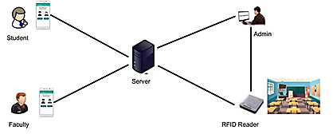
Figure 1: System Architecture for IoT based Smart College Campus using RFID
The above pictorial representation shows the various devices and their connections with other devices which provide the project the hardware as well as the storage requirements of this project. The server plays a key role in this system as it hosts the web application as well as handles the various requests from the devices.
The smart phones provide the user-interface for the faculty and students for the various functionalities provided by the system. They all communicate through the server which hosts the various functionalities provided by the system. The platform supported by our project currently is Android but can be expanded to various other platforms such as IOS, Windows, Firefox OS, etc. The RFID system plays a crucial role in the attendance module of our system.

OVERALL SYSTEM FUNCTIONALITY
As mentioned earlier, System design has to provide detailed description of the modules involved to achieve the various goals. This system provides various functionalities divided into modules which form the basis of the system design architecture. The various modules involve various actors on the scene according to their requirements, hence it is critical to design it meticulously and without a flaw as it will stand as the backbone of the entire system implementation and its final working. The below given block diagram provides the overall functionality design of the system.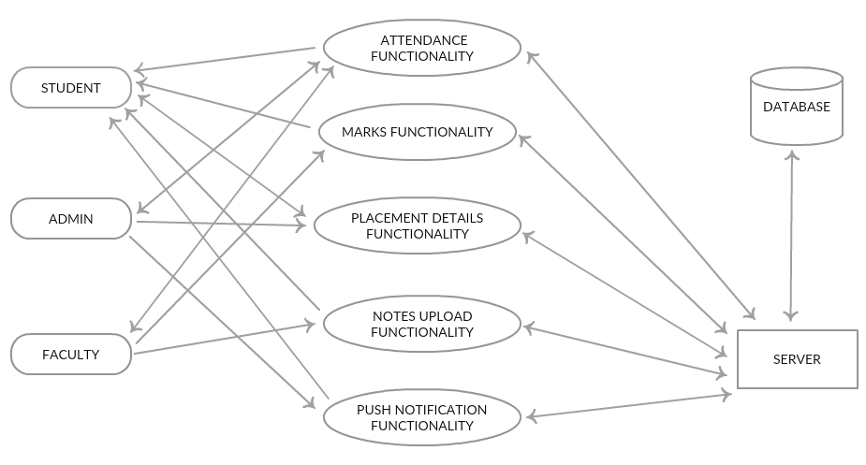
Figure 2: Block Diagram of System Functionality

REQUIREMENTS

SOFTWARE REQUIREMENTS
- Navicat for MYSQL
- Net Beans for Java
- JDK 8
- Android Studio
- OpenCV for Java

HARDWARE REQUIREMENTS
- RFID USB reader
- Camera
- Android phone

implementation
The project implements Android Studio, MySQL 5.1, Navicat for MySQL, HTML, CSS, JAVA. JDBC API is used for connectivity between the Java programming language and MySQL and Bootstrap has been used for front end. The project is capable of running on standard internet web browsers. The interface is used to bridge the gap between students, teachers and the administration.

ATTENDANCE
Algorithm Attendance details
Input: Students’ USN retrieved from temp_attendance Output: Attendance count for each subject
if faculty credentials are valid then
The students list pops out for his subject from the temp_attendance table and proxy checking is performed.
if (number of students captured by the camera) = (number of students in the list) then
faculty clicks on update to store into the
Final attendance table.
else
faculty checks for those who were absent, unchecks them and updates.
endif
else
credentials invalid.
End

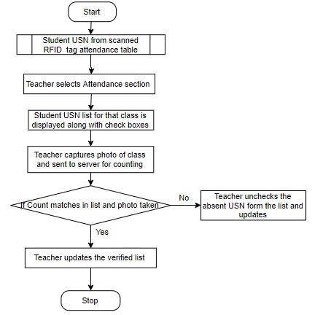
Figure 3: Attendance Functionality Module

MARKS
Algorithm View and updation of marks by student and
faculty
Input: Subject wise marks of the students and list of
students of a class
Output: Marks for the subject corresponding to the
student is viewed. Marks are viewed and updated by the faculty
if faculty or student logs in then
Student navigates to the marks section and selects
the subject.
Marks of IA1, IA2, IA3 are viewed.
Teacher navigates to the marks section
if (he selects view functionality) then
He selects the subject code.
Marks along with student’s USN is viewed.
else
He selects update functionality.
He selects subject and class.
List of students with USN and marks is displayed.
Faculty clicks on a USN and insert marks.
Marks are updated.
endif
end

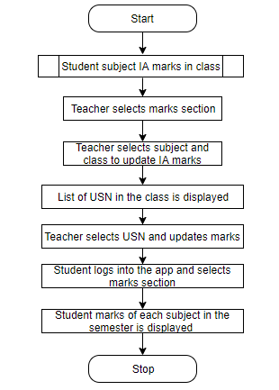
Figure 4: Marks Functionality Module

PLACEMENT
Algorithm Placement details for the students
Input: Student’s aggregate
Output: List of companies the student is eligible for.
if Student logs in then
Student navigates and enters his aggregate
if (aggregate >= 75) then
T1, T2, T3 companies are displayed.
endif
if (aggregate >= 60) then
T2, T3 companies are displayed.
endif
if (aggregate >= 50) then
T3 companies are displayed.
else
It displays “NOT ELIGIBLE”.
endif
end
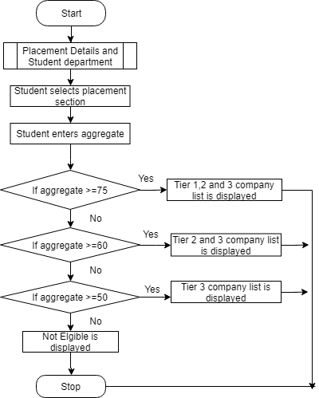
Figure 5: Placement Functionality Module

NOTES UPLOADING AND DOWNLOADING
Algorithm Notes upload and download
Input: Notes to be available in (.pdf) format
Output: Notes downloaded into the local device by the student or uploaded to the server by the faculty
if Student or faculty logs in then
Student or faculty navigates to notes section.
if (student navigates to notes section) then
A list of notes is shown.
Student selects the notes and it is downloaded.
endif
if (faculty navigates to notes section) then
He selects the semester.
He selects the file (.pdf).
Uploads it.
endif
end

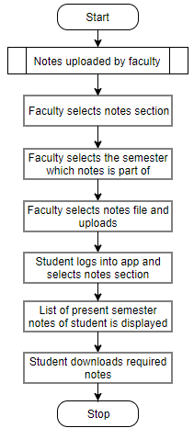
Figure 6: Notes Functionality Module

ACTORS ON THE SCENE
- Students
- Faculty
- Admin

- Admin
Admin plays an important role. He’s given a portal to handle the entire system, once the login is successful it will lead to the next page. The query written interacts with the admin_ information table to verify whether right details have been inserted.
Admin has options like Functionality, Placements, Attendance.
Functionality includes viewing, adding, deleting and updating student or faculty information.
Placements option presents different fields for the admin to enter various companies visiting the campus and their requirements
Attendance is used assign RFID to every student. The RFID reader detects the tag and the student is assigned with a unique ID.
- Students and Faculty
Student is given four options of viewing his Marks, attendance, placements details and finally downloading the notes. A tap on Marks will view the score gained by the student in each internal assessment. The table gives us the marks taken in every subject in that semester. Placements option gives an idea of student’s eligibility, he/she can enter his percentage to check out the companies they can apply or are eligible for. Notes section gives away all the notes uploaded by the teacher for that semester.
Faculty will be able to update attendance and marks of students. The faculty can also upload notes for the students in the application. Faculty will receive list of students to update the attendance. Faculty can update the marks for the section and semester he’s assigned to for each student.

result analysis
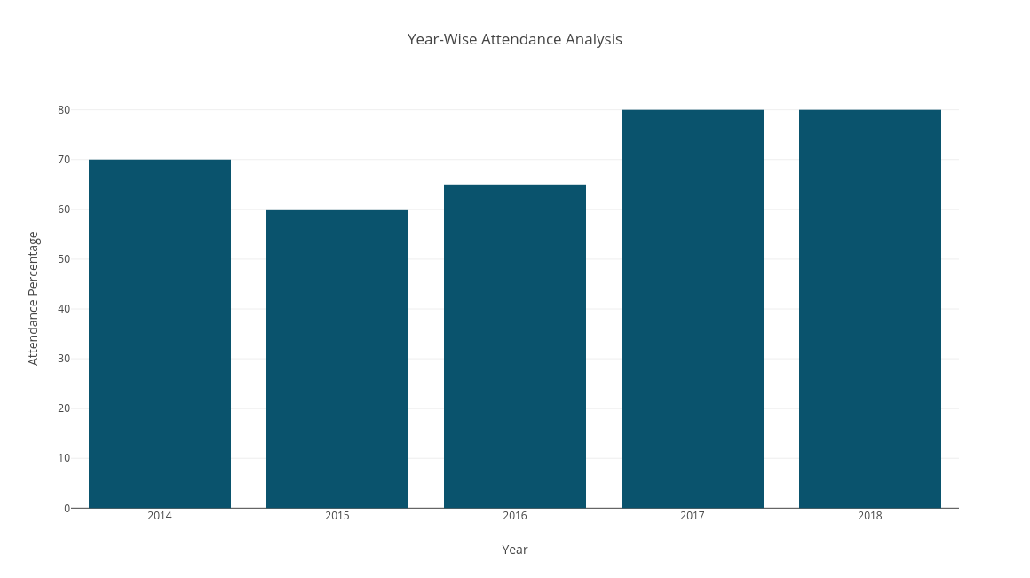
Figure 7: Attendance analysis
This graph represents the average attendance percentage for a single subject over a period of 5 years. X-axis represents the years, and Y-axis represents attendance percentage which can help in analyzing the student’s interest in that subject. Similar graphs can be represented through our data which is collected and can be used for performance analysis which will in turn help the department to improvise on those areas.

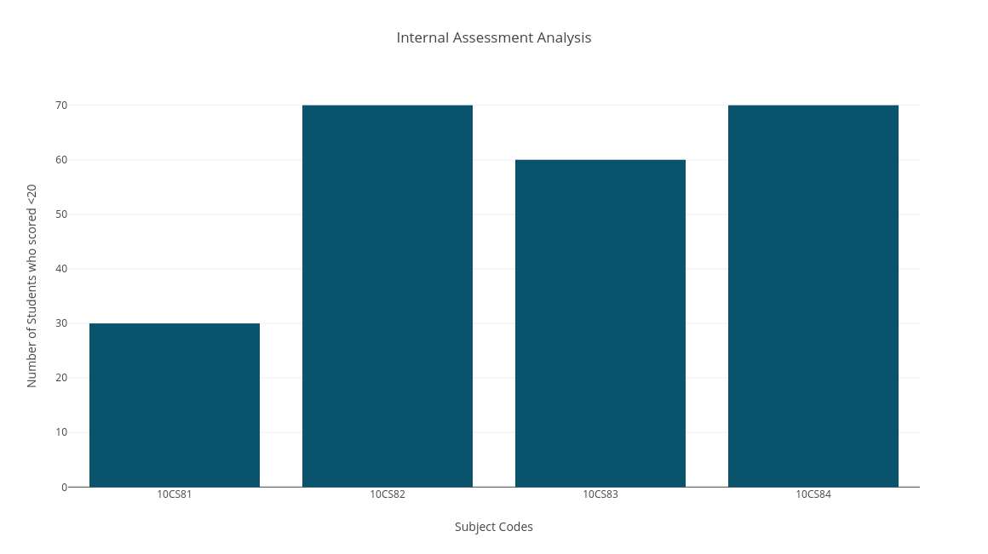
Figure 8: Internal Assessment Marks analysis
This graph represents the IA marks analysis for each subject for a particular sem. X-axis represents Subject codes and Y-axis represents number of students score <20. This will help in analyzing student's overall subject weakness and necessary steps can be taken in order to improvise.

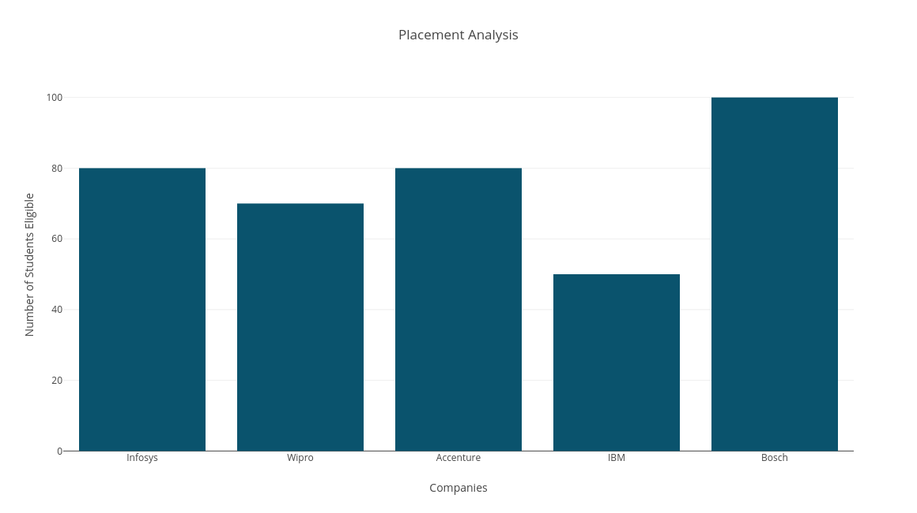
Figure 9: Placement analysis
This graph represents the placement analysis for each company. X-axis represents number of students eligible and Y-axis represents companies. This can help in analyzing students count for a company which can be used for betterment of placement in college.

Conclusion
As we are running towards a much smarter and technology driven world, where manual work has become a thing of the past, our proposed Campus Bridge project is definitely going to be a step in the right direction. It will not just provide efficient solutions to various day-to-day functionalities carried out in an educational institution, but also gives a scope to more technology driven approach to our educational system. Tablets will replace all the books, RFID tags will replace all ID cards, as digitalization takes over the way in which our colleges and institutions run. This project is not just about the end of the traditional ways of college working but more about the dawn of a new, modern and technology-driven approach to bridge the gap between students and campus. Our project aims to eliminate the current traditional way of record management. The proposed work reduces the time spent on the manual process. The performance is improved through a better reliable system that is proposed. The cost is also reduced as the labour wages are eliminated. In future, we can enhance our project by replacing the RFID USB reader which always needs to be connected with a system with a Wireless enabled RFID reader which is more efficient and makes the project more flexible and portable. Another scope of improvement can be done in the field of image processing by using a much more efficient method to detect faces even in low light shots. The current project also can be expanded in various other functionalities such as the library department, even hostel and parking allotment and management to monitor and regulate these in much more efficient way. We are also working upon bringing up our apps in various other platforms such as Windows, IOS, Firefox OS, etc. to enable a much wider reach to the project.
References
- Manual Required for Java Servlet and database handling URL: https://www.javatpoint.com/
- Firebase Cloud Messaging Service Manual URL: https://firebase.google.com/
- Herve Chabanne, Pascal Urien, Jean‐Ferdinand Susini., RFID and the Internet of Things, Wiley Publications, pages 57-218, New York, Mar 2013.
- Prof. Sagar Rajebhosale, Mr. Shashank Choudhari, Mr. Sachin Patil, Mr. Akshay Vyavahare, Mr. Sanket Khabiya., SMART CAMPUS – An Academic Web Portal with Android Application., IRJET, Volume 3, Issue 4, pages 389–394, Apr. 2016.
- Lalit Mohan Joshi., “A Research Paper on College Management System. International
- Chitresh, S and Amit K,” An efficient Automatic Attendance Using Fingerprint Verification Technique”, International Journal on Computer Science and Engineering (IJCSE), Vol. 2 No. 2, pp 264-269. Dec 2010E.
- M.R.M.Veeramanickam, Dr. M. Mohanapriya., IOT enabled Futurus Smart Campus with effective E-Learning : I-Campus, GSTF Journal of Engineering Technology (JET) Vol.3 No.4, , pages 81-87, Apr. 2016.
- C. E. Geoffrey, “Automatic Access Control System using Student’s Identification Card based on RFID Technology”, Unpublished Thesis Faculty of Electrical Engineering, University of Teknologi Malaysia, Jan 2012.
- Pranay Kujur and Kiran Gautam, "Smart Interaction of Object on Internet of Things", International Journal of Computer Sciences and Engineering, Volume-03, Issue-02, Page No (15-19), Feb -2015.
- Karan Phougat, Mohit Sinha, Samarth Pruthi and Sachin B. Wakurdekar, “An IoT Approach for Developing a Smart Campus”, IJIRCCE, Vol. 5, Issue 4, pp. 7405 – 7412, April 2017.
- KristianHentschel, DejiceJacob,Jerem Singer, and Matthew Chalmers , "Supersensors Raspberry Pi Devices for Smart Campus Infrastructure (short paper)", 2016 IEEE 4th International Conference on Future Internet of Things and Cloud ,Year:2016
- Marian Cata, "Smart University, a new concept in the Internet of Things" IEEE Conference Publications, Year:2016
- N. Sastra and D. Wiharta, "Environmental monitoring as an IoT application in building smart campus of Universitas Udayana", 2016 International Conference on Smart Green Technology in Electrical and Information Systems (ICSGTEIS), Vol.3, pp. 85-88, 2017
- Anugerah Ayu and Barroon Ismaeel Ahmad, “TouchIn: An NFC Supported Attendance System in a University Environment”, International Journal of Information and Education Technology, Vol. 4, No. 5, pp. 448 – 453, October 2014
- Intelligent Device-to-Device Communication in the Internet of Things Oladayo Bello, Member, IEEE, and Sherali Zeadally, Senior Member, IEEE, Dec 2018
- Akshara Jadhav, Akshay Jadhav, Tushar Ladhe and Krishna Yeolekar, “Automated Attendance System Using Face Recognition”, IRJET, Vol. 04, Issue 01, pp. 1467 – 1471, Jan 2018.

 

